**Android Internship Report**

**Personal Details**

Name : Bharat Raj

College Name : SVIT,vasad

Degree : BE

Semester : 7

Github URL :<https://github.com/bharat-svit/AkashTechnolabs>

**Company Details**

Company Name : Akash Technolabs

External Guide : Akash Padhiyar

Training Duration : 26-05-2021 to 21-06-2021

**Index**

|  |  |  |
| --- | --- | --- |
| **Index** | **Task Detail** | **Page Name** |
| 1 | HelloApp | 1 |
| 2 | IntentApp |  |
| 3 | UI Controls |  |
| 4 | Welcome screen |  |
| 5 | Splash Screen |  |
| 6 | Scroll view |  |
| 7 | Grid view |  |
| 8 | Scrollview |  |
| 9 | Login screen |  |
| 10 |  |  |
|  |  |  |

Note : You can Add Minimum 15 Screenshots and Maximum 50

Also Write Description in Each page

1 HelloApp

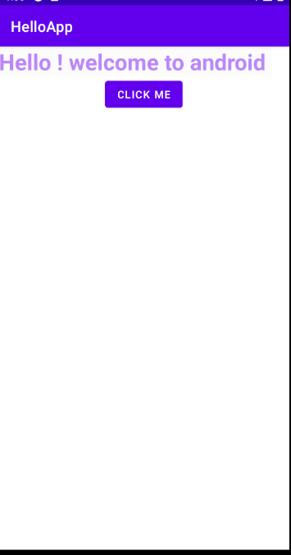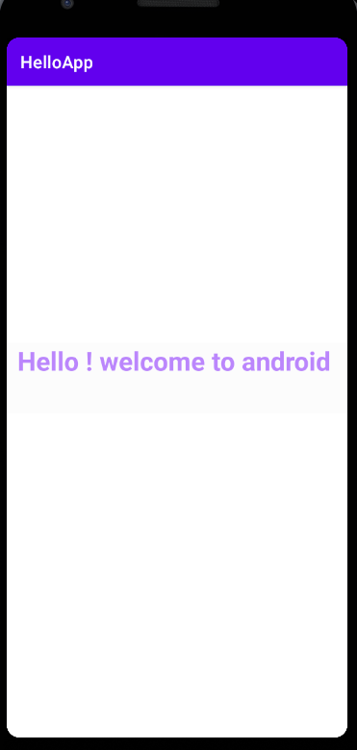

* It displays simple screen saying hello. On clicking button it shows toast message on screen .

2) IntentApp

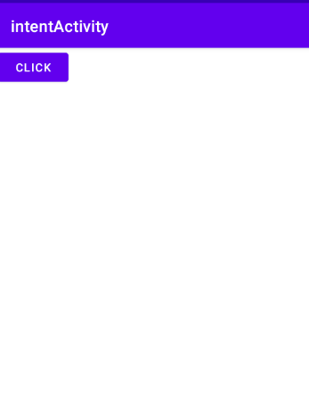 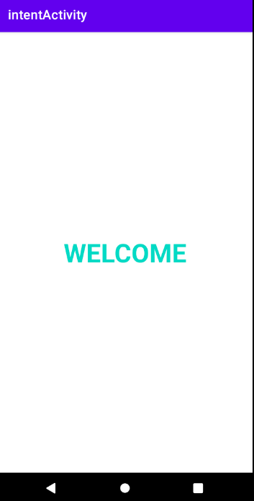

* On clicking button its will move to next screen i.e on welcome screen

3)UI controls (Buttons , textview , radio button , checkbox)

Various UI controls displan and shows text message as toast

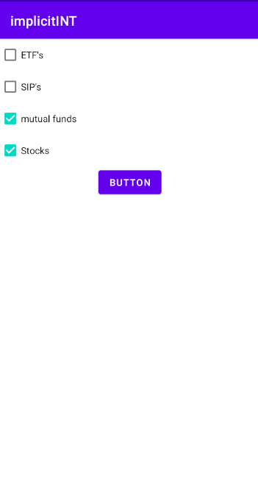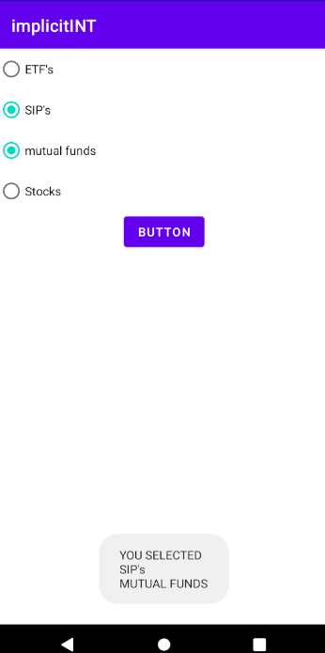

4) Welcome Screen

It sends data to another activity . simple welcome screen that implements it .

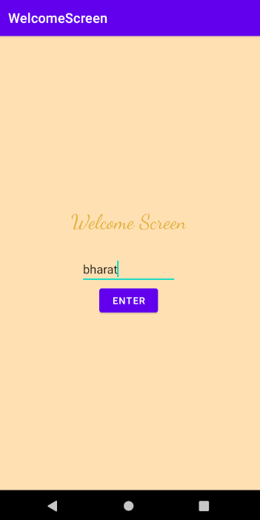 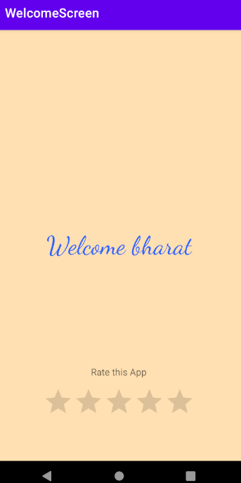

5) Splash App

Shows splash screen for 5ms .and then moves to next screen

 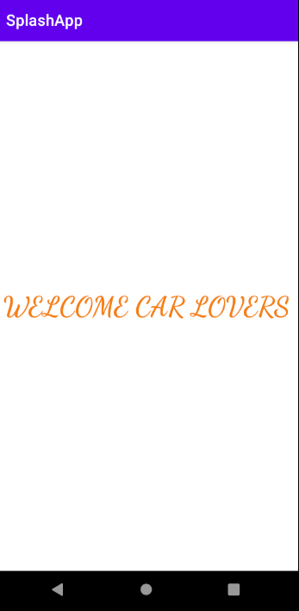

6) scroll view

Shows vertical and horizontal scroll

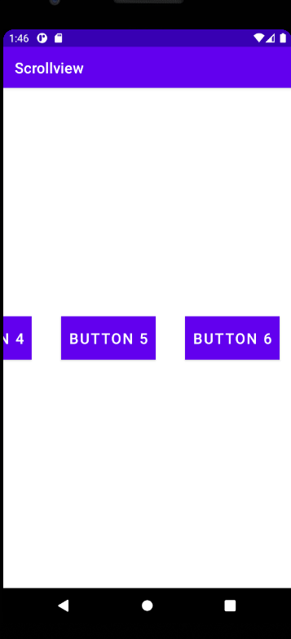 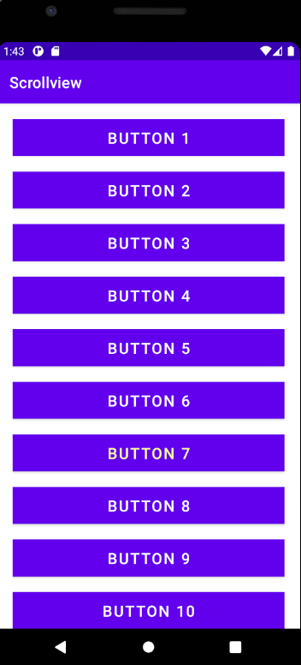

7) List view

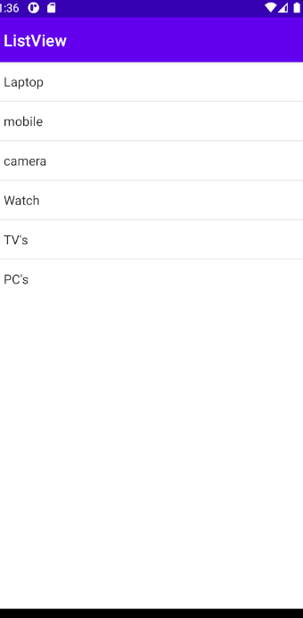

8) Grid View

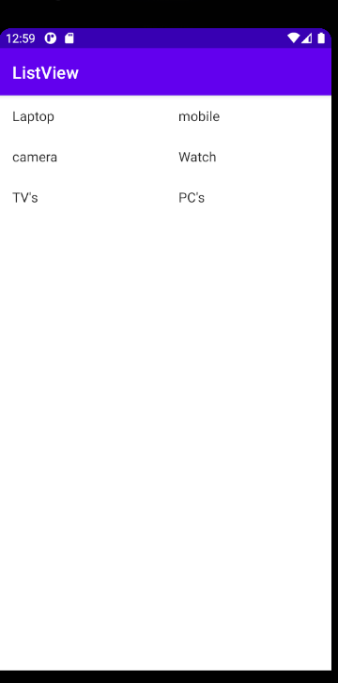

9) Login App

Save login info for further log-in into app

